**Neighborhoods of Baltimore: People, Crime, and Venues**

4/09/2020, CJRR

# 1. Introduction:

1.1: Objective:

Characterize Baltimore’s neighborhoods in terms of their crime rates, age of the residents, population density, median household income, and venues.

## 1.2: Background:

**Client:** The principal client for this project is Jane New Resident. She is a 38-year-old female professional who is moving to Baltimore. To start her house hunt, she is looking to identify low crime neighborhoods, with grocery stores, shops, restaurants and other professionals.

**Baltimore:** Nick named “Charm City”, Baltimore is the most populous city in Maryland. It is home to the world-renowned Johns Hopkins University and Hospital and numerous tourist destinations including the Pimlico Race Course, the Inner Harbor, and the Maryland Science Center. However, crime in Baltimore is far above the national average and the city has a practically high murder rate. The city is divided into nine geographic regions and over 50 neighborhoods: each neighborhood having its own character. The city’s crime is generally concentrated in the neighborhoods with high rates of poverty. [1]

## 1.3. Analytic Approach:

To help Jane select neighborhoods for her house hunt, this analysis will collect and generate summary data on the crime, number and type of venues, median income, age, and household size, for each neighborhood. It will then cluster the neighborhoods, summarize each cluster and display the information in an interactive map. This will allow Janes to review the character of each cluster and selects a subset of neighborhoods to start searching in.

# 2. Data:

2.1 Data Requirements:

The analysis described in 1.3 will require the following data:

* List of the neighborhoods in Baltimore
* The geographic boundaries of the neighborhood
* General crime statistics for each neighborhood
* General demographic statistics for each neighborhood
* Venue information for each neighborhood

The client wants to understand the general character of neighborhoods so she can start house hunting. She is worried about the crime rate. The analysis will need to include an overall picture of the crime rate of each neighborhood.

She is looking to live near other like-professionals – a factor that is not easy to characterize. However demographic information may help identify those neighborhoods – specifically by examining the median income, the average household size, and the percentage of people that are in the 25 to 64-year-old age group. Because the crime rate is related to the high poverty areas, the analysis will include that as well.

She is interested to understand the character of neighborhoods in terms of the available shopping and restaurants. For each neighborhood a listing of the type and number of nearby venues will be used.

There are over 50 neighborhoods in Baltimore. The client wants to consider them in like character clusters so that she does not over-constrain her house-hunting options.

## 2.2 Data sources:

2.2.1 Crime and Safety:

2015 Crime and Safety data for Baltimore City is available on Data.gov here:

<https://catalog.data.gov/dataset/crime-and-safety-2015>

This data set represents the year 2015’s values for Crime and Safety from Vital Signs published by the Baltimore Neighborhood Indicators Alliance. For more information, please visit http://www.bniajfi.org/vital_signs.

The crime statistics are organized by neighborhood and includesthe following features:

* Part 1 Crime Rate per 1,000 Residents
* Violent Crime Rate per 1,000 Residents
* Property Crime Rate per 1,000 Residents
* Juvenile Arrest Rate per 1,000 Juveniles
* Juvenile Arrest Rate for Violent Offenses per 1,000 Juveniles
* Juvenile Arrest Rate for Drug Offenses per 1,000 Juveniles
* Rate of 911 Calls for Service for Shootings per 1,000 Residents
* Rate of Gun Homicides per 10,000 Residents
* Rate of 911 Calls for Service for Common Assaults per 1,000 Residents
* Rate of 911 Calls for Service for Narcotics per 1,000 Residents
* Rate of 911 Calls for Service for Auto Accidents per 1,000 Residents
* Adult Arrest Rate per 1,000 Adults

For this analysis, of the above options, the following statistics will be included:

* Part 1 Crime Rate per 1,000 Residents
* Violent Crime Rate per 1,000 Residents
* Property Crime Rate per 1,000 Residents

Example:

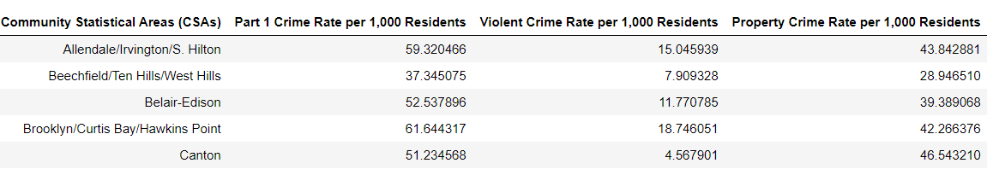

### 2.2.2 Demographics:

2015 Census demographics data for Baltimore City is available on Data.gov here:

<https://catalog.data.gov/dataset/census-demographics-2015>

This data set represents the year 2015’s values for Census Demographics from Vital Signs published by the Baltimore Neighborhood Indicators Alliance. For more information, please visit <http://www.bniajfi.org/vital_signs>.

The demographics statistics are organized by neighborhood and includes the following features:

* Percent of Residents - Black/African-American
* Percent of Residents - White/Caucasian Percent of Residents - Asian
* Percent of Residents - Two or More Races
* Percent of Residents - All Other Races
* Percent of Residents - Hispanic Racial Diversity Index
* Percent of Population Under 5 Years Old
* Percent of Population 5-17 years old
* Percent of Population 18-24 years old
* Percent of Population 25-64 years old
* Percent of Population 65 years and over
* Total Number of Households
* Percent of Female-Headed Households with Children Under 18
* Percent of Households with Children Under 18
* Average Household Size
* Median Household Income
* Percent of Households Earning Less than $25,000
* Percent of Households Earning $25,000 to $40,000
* Percent of Households Earning $40,000 to $60,000
* Percent of Households Earning $60,000 to $75,000
* Percent of Households Earning More than $75,000
* Percent of Family Households Living Below the Poverty Line
* Percent of Children Living Below the Poverty Line

For this analysis, of the above options, the following statistics will be included:

* Percent of Population 25-64 years old
* Average Household Size
* Median Household Income
* Percent of Family Households Living Below the Poverty Line
* Total Number of Households – to calculate population density

Example:

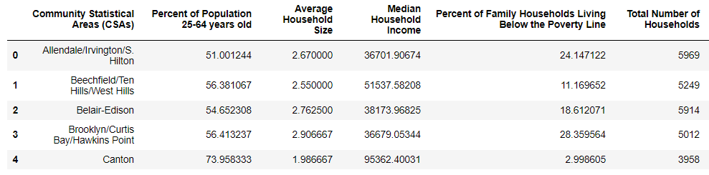

### 2.2.3 Neighborhoods and Boundaries:

Both the demographics and crime data sets include a list of neighborhoods names and geographic boundaries. See below for a map of Baltimore Community Statistical Areas, hereafter referred to as neighborhoods, and the centroid of each neighborhood:

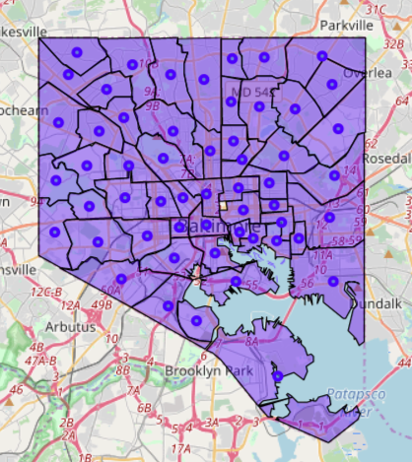

Figure: Baltimore Neighborhoods

### 2.2.4 Venues types and Counts:

Foursquares will be used to generate a list of venues near each neighborhood’s center.

. 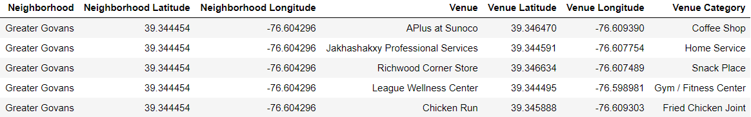

# 3. Methodology:

## 3.1: Data Wrangling:

### 3.1.1 Formatting and reformatting….

The 2015 crime and statistics and census data files posted on data.gov were a mess. The json files were not in a readable format. The CSV files had formatting inconsistencies. All the data was present, however to make it workable it had to be manually reformatted. When completed there were three files, a CSV containing the crime and safety data, a CSV containing the census data, and a GEOJSON file containing multipolygon shapes for each neighborhood. The reformatted files are posted here:

GEOJSON:

<https://github.com/AstroCris/CoureraCourses/blob/master/Baltimore44.geojson>

2015 Demographics:

<https://github.com/AstroCris/CoureraCourses/blob/master/Census_Demographics__2015__data_clean.csv>

2015 Crime and Safety:

<https://github.com/AstroCris/CoureraCourses/blob/master/Crime_and_Safety__2015__data_clean.csv>

### 3.1.2 Reading and Slicing:

**GEOJSON:**

Simply reading the GEOJSON file and using Folium to produce a choropleth map produces the desired result. Each region the that corresponds to a neighborhood is colored. The color has no value in this example.

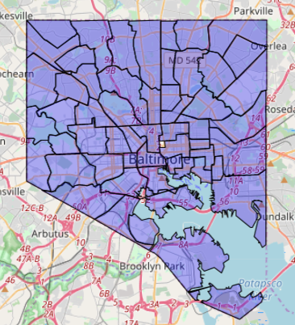

Figure: Neighborhoods

The uncolored region in the center of the city, initially was a concern. However, that region corresponds to the city jail. The data sets do not include any crime or demographics information for this region, nor is it relevant to our house hunting client.

**2015 Crime and Safety Data:**

Using pandas to read the crime and safety CSV file produces the following dataframe (as viewed with .head() )

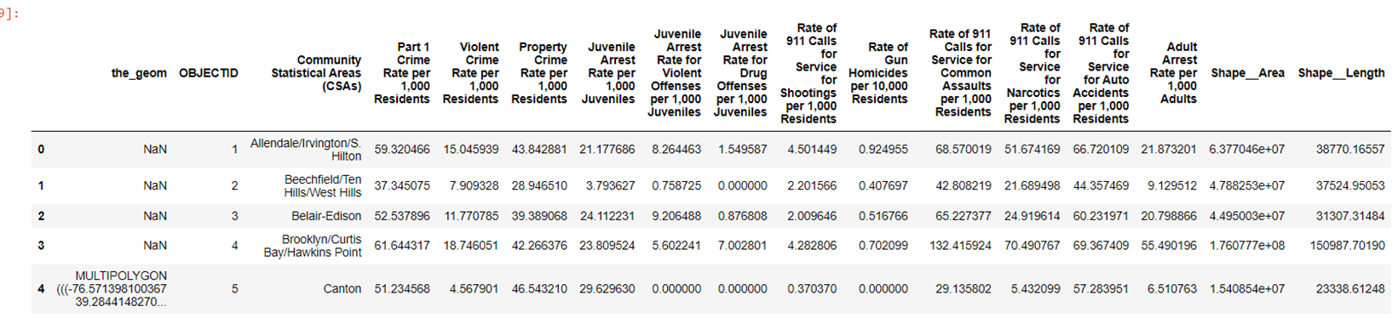

The NaN entries in the *the_geom* column are entries where the multipolygon was corrupted in the CSV and were manually removed. Those entries were corrected manually in the GEOJSON file.

Selecting the desired features (as discussed in section 2.2.1) and simplifying the column names produces the following dataframe:

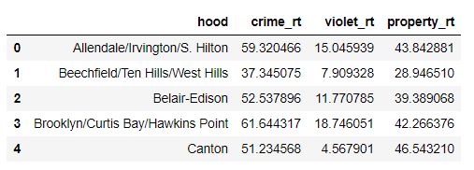

**2015 Demographics:**

Using pandas to read the 2015 Census CSV file produces the following dataframe (as viewed with .head() )

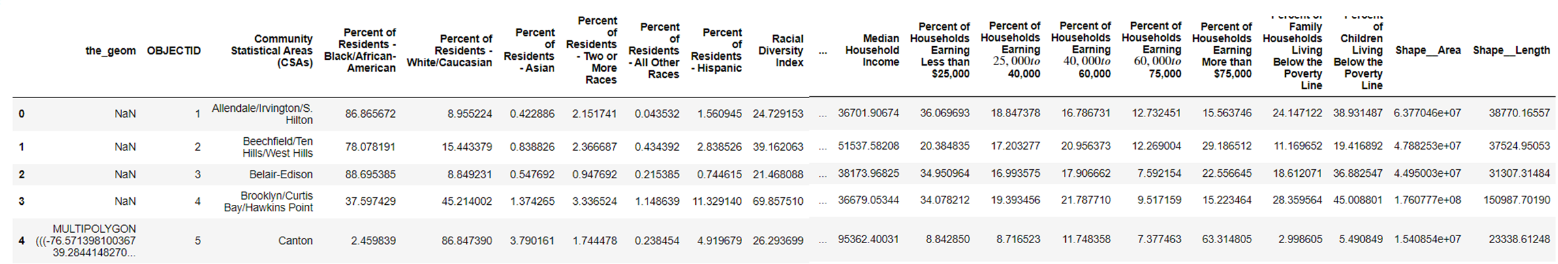

The NaN entries in the *the_geom* column are entries where the multipolygon was corrupted in the csv and were manually removed. Those entries were corrected manually in the GEOJSON file.

Calculate population density per acre by multiplying the total number of households by the average household size and dividing by the area of the neighborhood. Multiplying the result by 43560 converts the result from 1/ft2 to 1/acres.

Selecting the desired features (as discussed in section 2.2.2) and simplifying the column names produces the following dataframe:

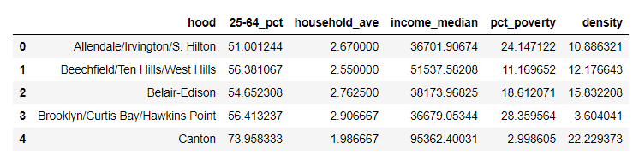

### 3.1.3 Neighborhood Coordinates

The GEOJSON file contains the multipolygon shape of each neighborhood, expressed as a list of latitude and longitude coordinates. However, the Foursquares API requires a single coordinate point (expressed as latitude and longitude) and a radius (in meters).

The GEOJSON data should be sufficient to calculate reasonable center coordinates for each neighborhood. As a first attempt the average of the latitudes and longitudes for each neighborhoods’ multipolygon was calculated. However, this produced erroneous results:

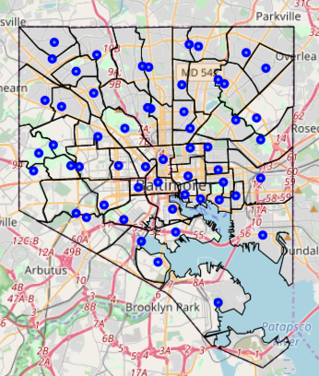

Figure: Neighborhood centers calculated by averaging

This averaging method is biased by the density of points needed to define each edge. A more complicated edges requires more points to define it. This shifts the calculated average coordinates towards that edge.

A more mathematically valid approach is to calculate the centroid of the polygon shape. See [centroid](https://en.wikipedia.org/wiki/Centroid) for more information. The python library shapely has a function to do this. See [shapely](https://shapely.readthedocs.io/en/latest/manual.html#geometric-objects) for more information. Using this function produced superior results:

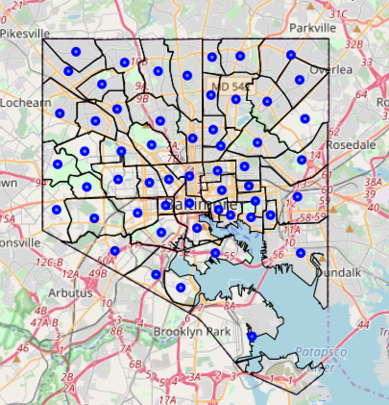

Figure: Neighborhood centroids

Centroid latitude and longitude for each neighborhood was loaded into a dataframe:

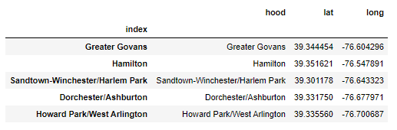

### 3.1.3 Venue Data:

Foursquare was used to collect a list of venues details (name, location, category) for venues within 1000 meters of each neighborhood’s centroid, up to 100 venues for each neighborhood. A total of 889 venues in 216 unique categories were collected. The result loaded into a dataframe has this form:

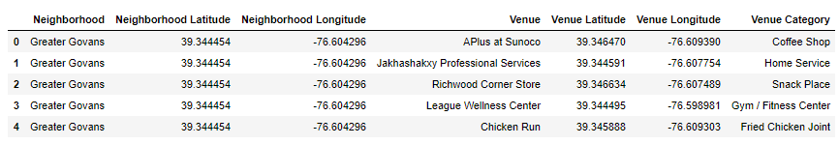

The geographic distribution of the 889 venues:

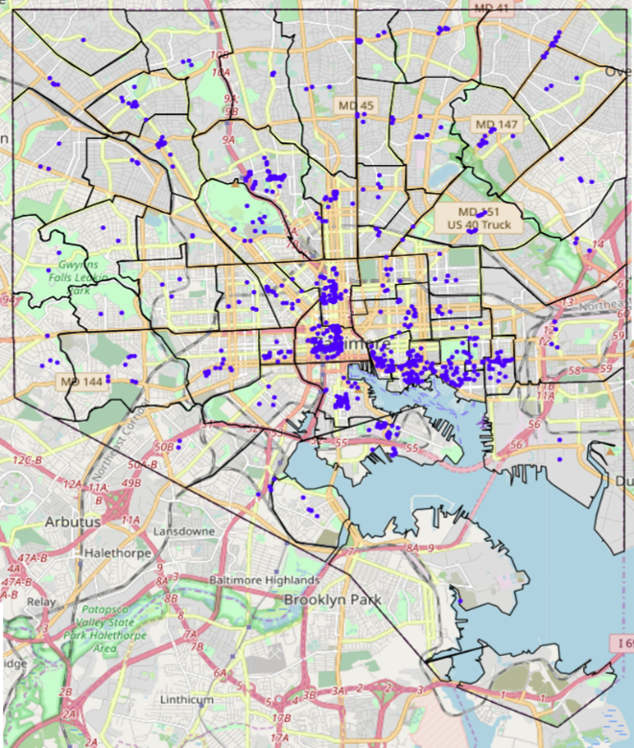

Figure: Foursquare venues with in 1000 m of each neighborhood’s centroid

On inspection some neighborhoods are sparsely populated with Foursquare venues. For example, Foursquares did not return any venues in Mount Washington Village, despite the presence of shops, restaurants, art galleries, a church, and a school in the village. Increasing the query radius did not resolve this problem. This calls into question the validity of all the results that follow. See Discussion for more detail.

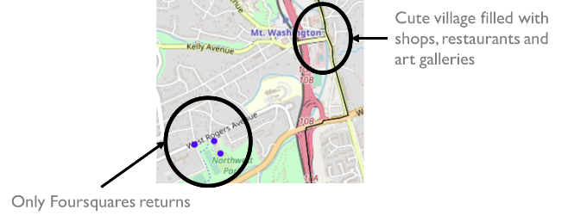

Figure: Where are the Mount Washington Village’s venues?

Since the objective is to characterize each neighborhood, the list of venues need to be translated into a summary for each neighborhood. First using one-hot-encoding the venue categories are converted into new columns and a ‘1’ is placed to indicate which category that venue is in. Zero is placed otherwise. The result has this form:

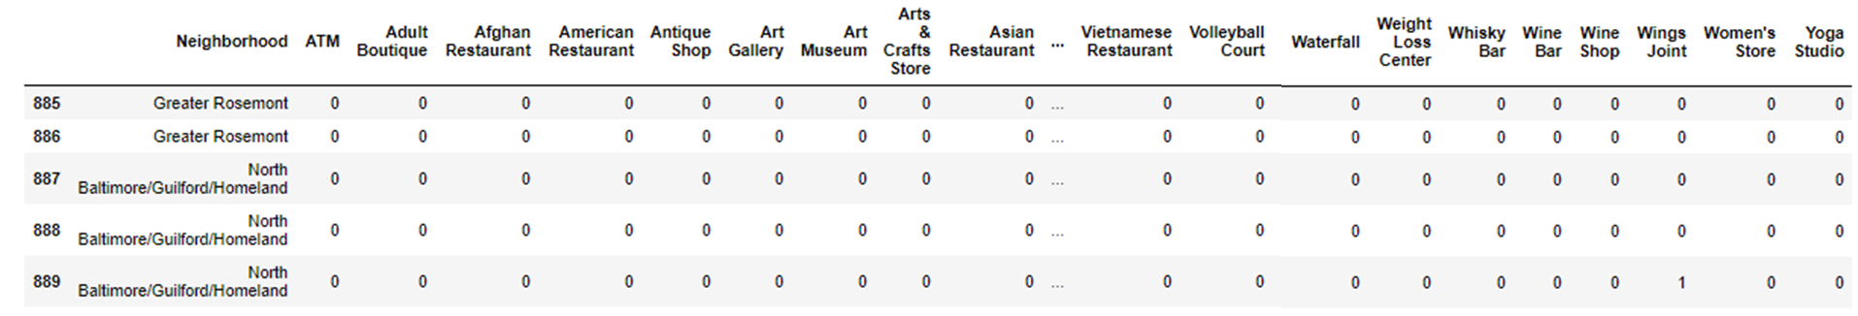

Next the venues are grouped by neighborhood, summing the number of venues for each category:

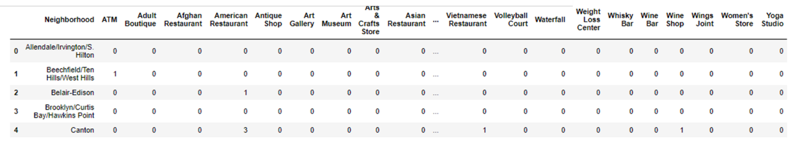

Now the venue data is in a form that is relevant to the analysis objective.

### 3.1.4 Merging DataFrames

Merging the crime, census, and coordinates data frames to make a data frame for summary information:

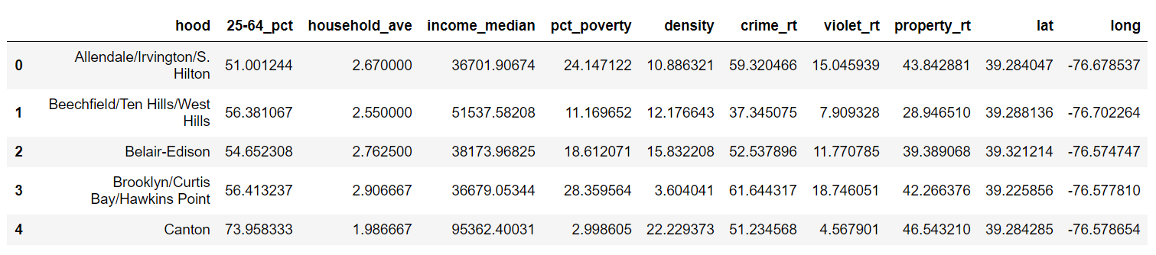

Merging the crime, census and venues counts data frames to make a data frame that contains the relevant data for clustering:

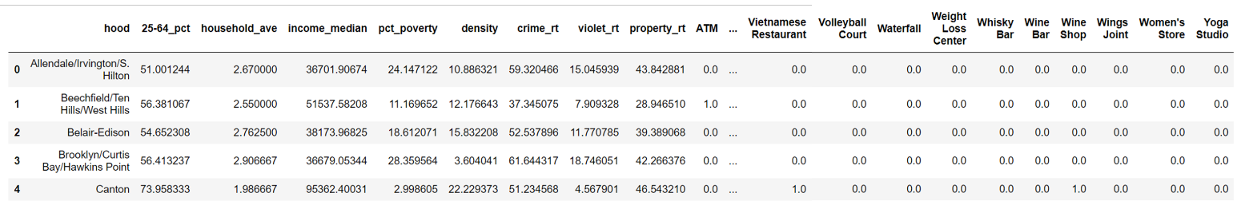

## 3.2: Data Exploration:

### 3.2.1 Crime Rate:

How do the crime rates vary from neighborhood to neighborhood?

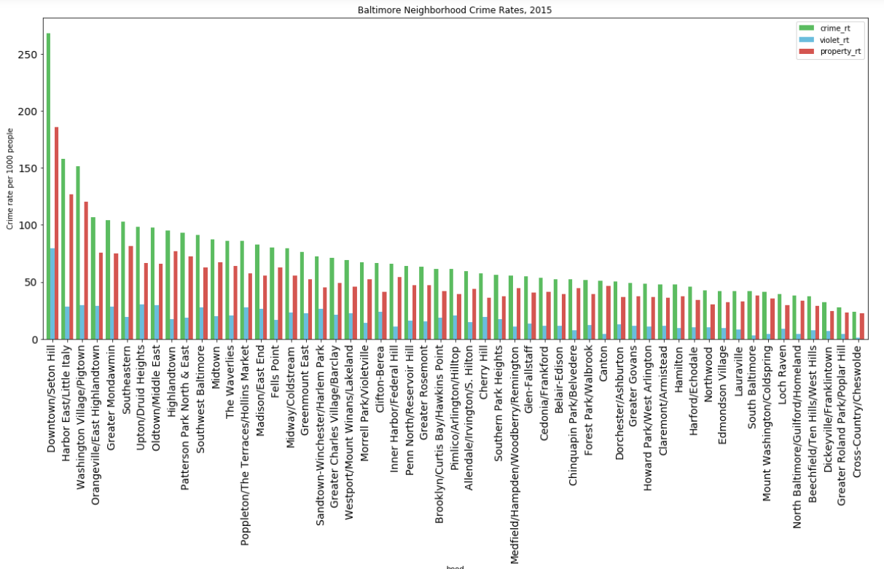

Figure: Total Crime rate (green), violent crime rate (blue), property crime rate (red) in 2015.

Geographically how do the crime rates vary?

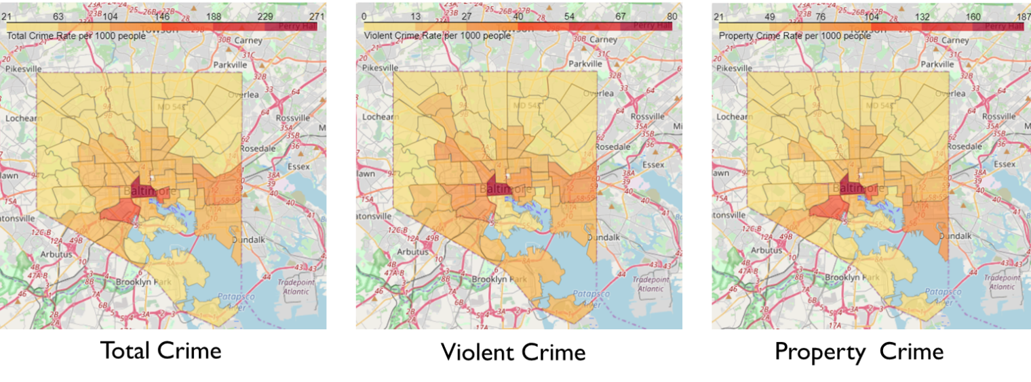

Figure: Geographic distribution of crime rates, per 1000 people, in 2015.

### 3.2.2 Median Household Income:

How does median household Income vary neighborhood to neighborhood?

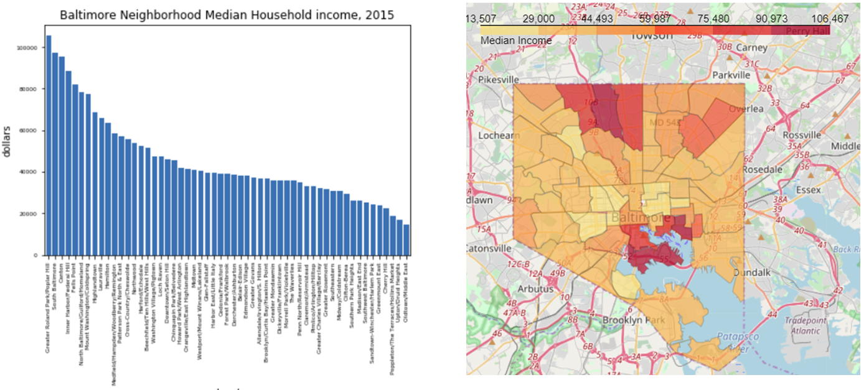

Figure: Median Household Income, 2015

### 3.2.3 Poverty:

How does the percentage of households in poverty vary neighborhood to neighborhood?

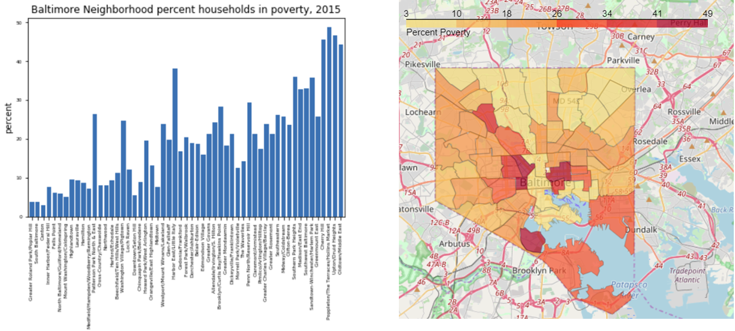

Figure: Percent of household in poverty, 2015

### 3.2.4 Working age population:

How does the percentage of the population that are 25 -64 years old vary neighborhood to neighborhood?

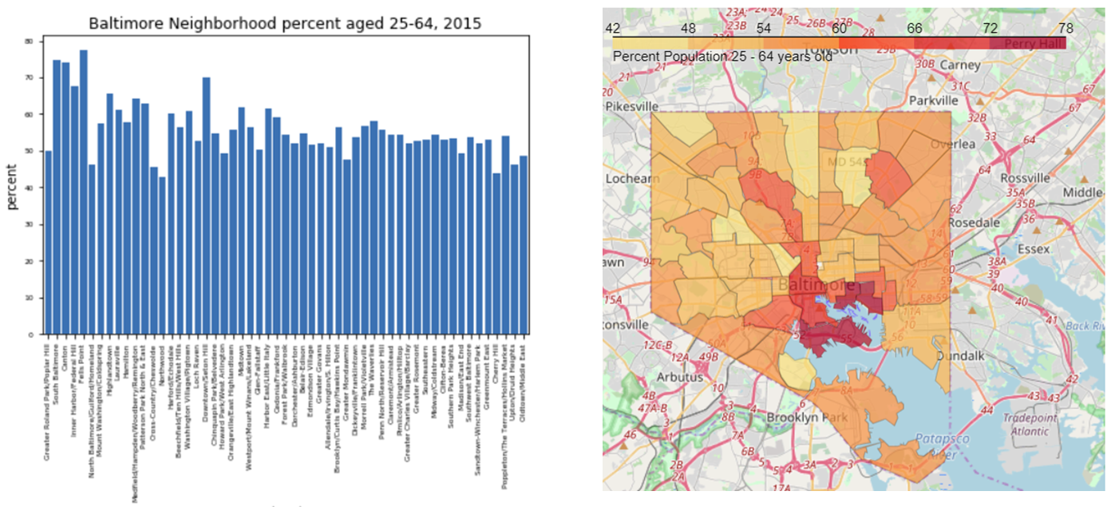

Figure: Percent of the population that is 25 -64 years old, 2015

### 3.2.5 Household size:

How does the average household size vary neighborhood to neighborhood?

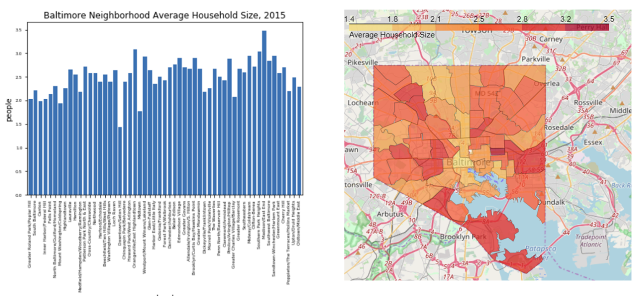

Figure: Average household size, 2015

### 3.2.6 Population Density:

How does the population density vary neighborhood to neighborhood?

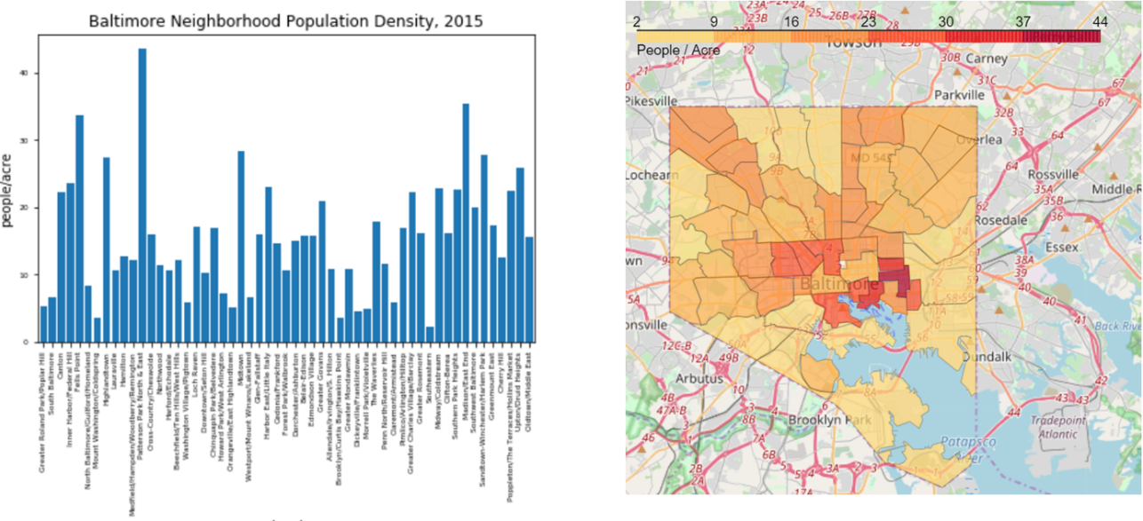

Figure: Neighborhood population density, 2015

## 3.3: Analysis:

### 3.3.1 Categorizing Statistical Data:

To help analyze and interpret the crime and census numerical data for each neighborhood, the numerical values for each feature was converted to a categorical value of very low, low, moderate, high, or very high. The categorical value ‘very low’ was assigned the lowest 10% of the feathers’ values, ‘low’ was assigned to lowest 10-30% of values, moderate to the lowest 30-70%, high the lowest 70-90% , and very high >90% (equivalently, the highest 10%).

The average household size feature was then corrected and assigned categories that were indicative of the household make up. Average household sizes less than 1.5 were assigned the category ‘mostly singles’, between 1.5 and 2.5 was assigned ‘mostly couples’, between 2.5 and 3 'couples & small families', and >3 was assigned the categorical value ‘families’.

The resulting values were added to the summary dataframe and has this form:

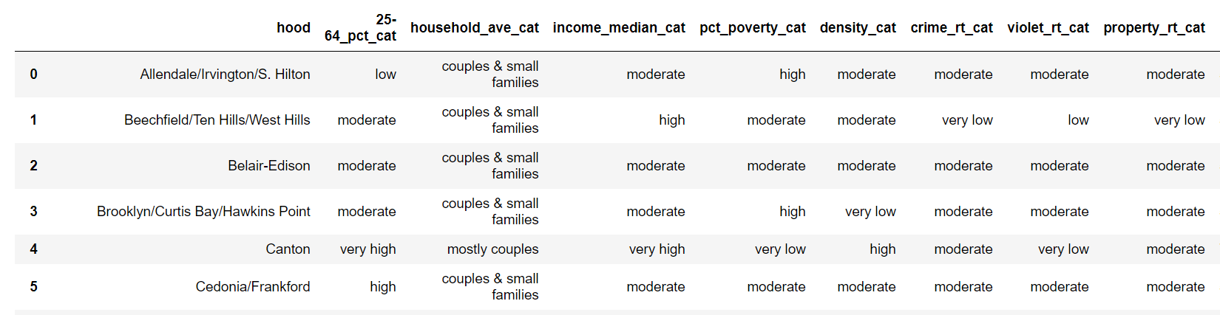

In the process of translating the numeric features to categorical values based on statistical distribution (<10%, 10-30% ect.) the numerical values of the slicing bins were saved. Thus recording numeric values that corresponds to the cuts for each feature. These values were save so that they are available to use later when analyzing the cluster average values for each feature.

## 3.3.2 Common Venues:

To aid in characterizing each neighborhood, the 7 most common venue types was tabulated. The result has the below form, which was then added to the summary dataframe. These new features will be used to generate summary reports for each recommended neighborhood.

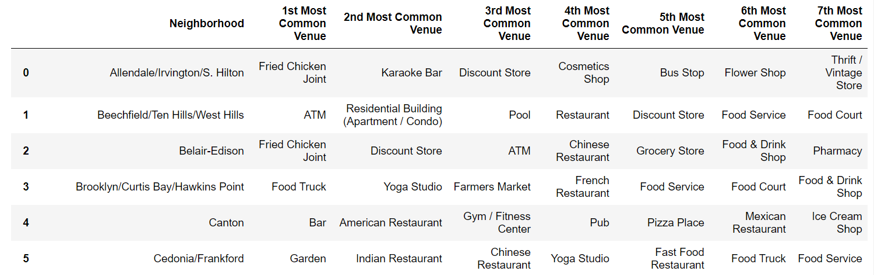

## 3.3.3 K-Means Clustering:

To group similar neighborhoods for the client’s conservation, K-Means clustering was applied to the ‘clustering’ dataframe (see 3.1.4). This data frame includes the crime and census data and the one-hot-encoded venue information complied for each neighborhood. (see 3.1.4)

Because the venue data was sparse for some neighbors, K-Means clustering was first attempted with only the non-venue information. The data was selected from the dataframe and then normalized using StandarScaler.

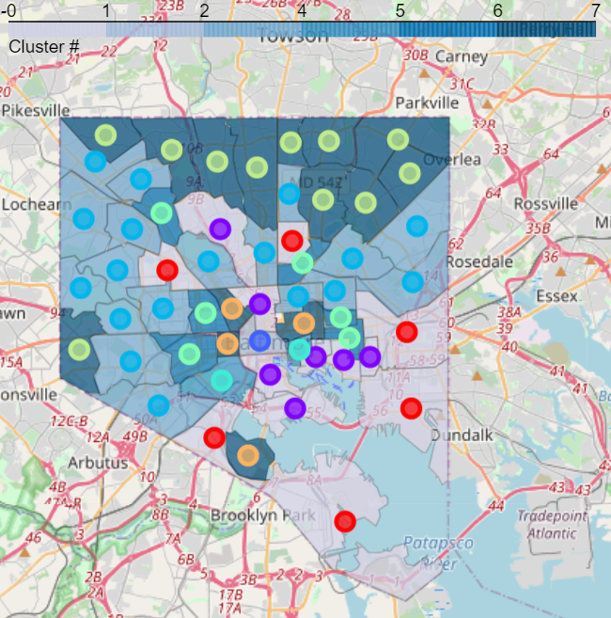

Figure: Clustered neighborhoods, 8 clusters, dot color and shade correspond to cluster number.

The algorithm was run with for different numbers of clusters and the results were visually inspected (see below). A domain expert who was familiar with the city, suggested that the 8 clusters results was adequate. (above). The 8-cluster result will be used in the rest of this analysis.

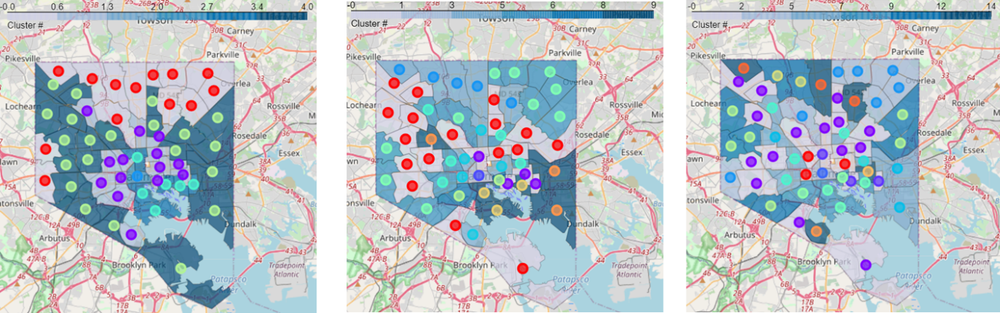

Figure: Clustering results for 5 (left), 10 (center), and 15 (rifht) clusters.

K-Means clustering was repeated to also include the one-hot encoded venue information. As before the data was first normalized using StandarScalarer. The KMeans algorithm was run with different numbers of clusters and the results were visually inspected (see below)

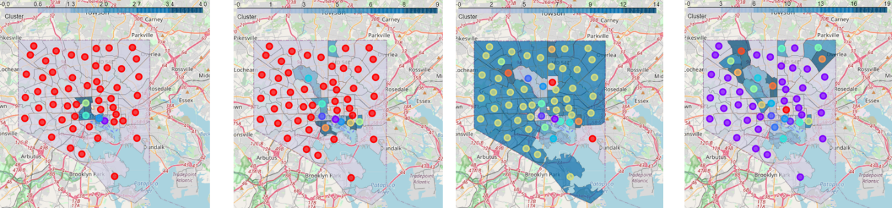

Figure: Clustering results for 5 (left), 10 (center left), and 15 (center right) and 20 (right) clusters.

The results of all the clustering attempts, that included the venue information, placed the majority of neighborhoods in a single cluster. Such a result is not useful for the client.

The best clustering result for current objective is for 8 clusters and without using the venue information.

### 3.3.4 Summarizing Clusters

To summarize the character of each cluster, the mean value of the features (including the venue counts) for the neighborhoods in that cluster was calculated:

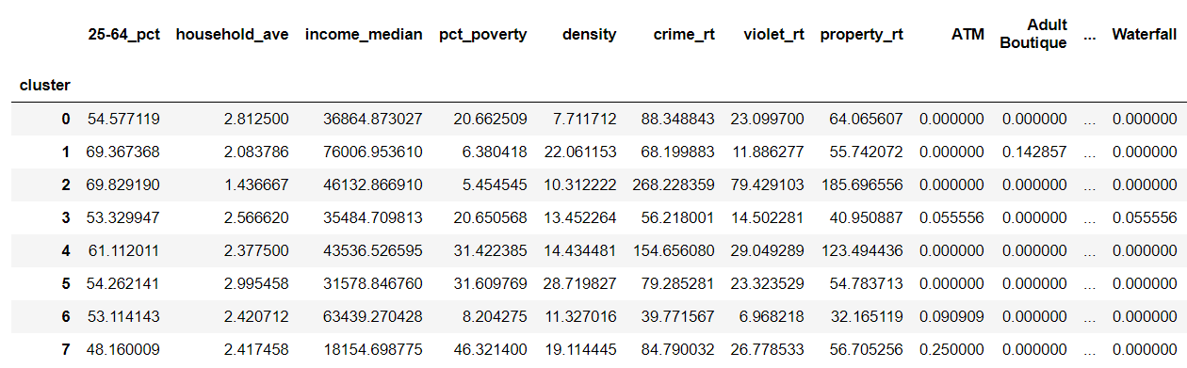

Then using the same bins from 3.3.1 (Categorizing Statistical Data) a categorical representation of the cluster average values was added to the dataframe using the same numerical limits as in 3.3.1. This ensures that ‘very high’ means a value that is among the top 10% of the value for all neighborhoods – and not the top 10% for values amongst the clusters means.

The 5 most common venues were tabulated for each cluster as well.

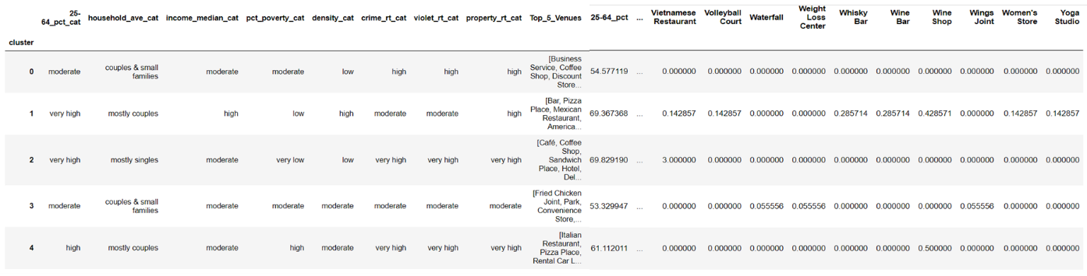

A summary report for each cluster was printed and manually reviewed by a human analyst. See Appendix A and section 4 for the cluster summary report and the analysts’ recommendations.

# 4. Results:

The above analysis clustered the 56 Baltimore neighborhoods into 8 clusters. Appendix A and the map and table below summarize the clusters.



Figure: Neighborhoods of Baltimore Clustered

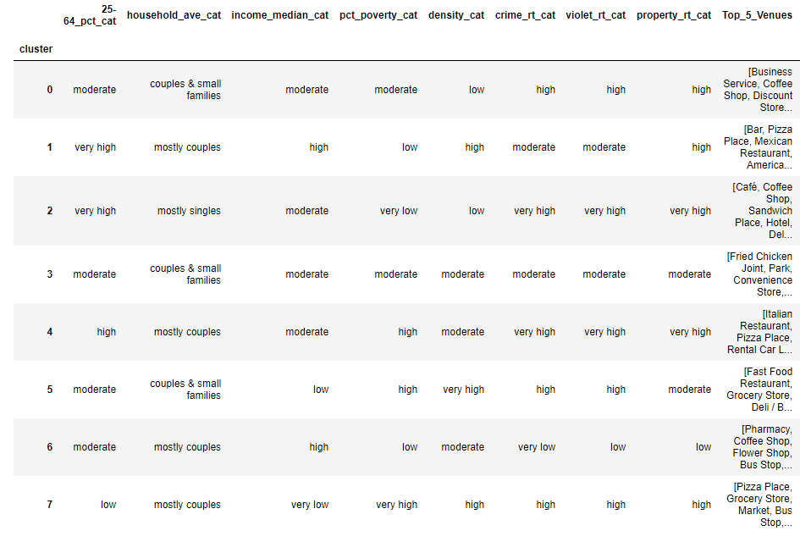

A human analyst examined the summary information of each of the clusters. The mean crime rate for clusters #2 and #4 is ‘very high’. Similarly, the mean crime rate for clusters # 0, #5, and #7 is ‘high’. The neighborhoods in these clusters are not suitable for the client.

Remaining clusters are #6, #3 and #1:

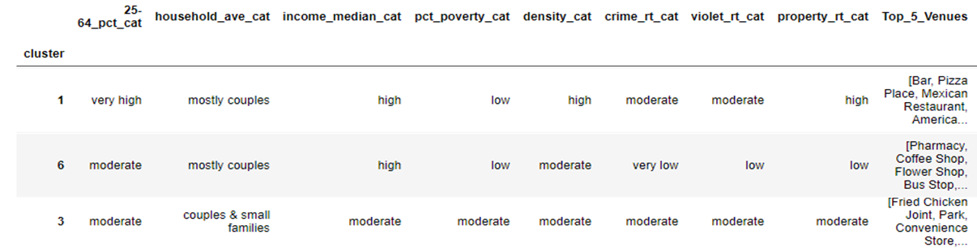

## 4.1 Cluster #6:

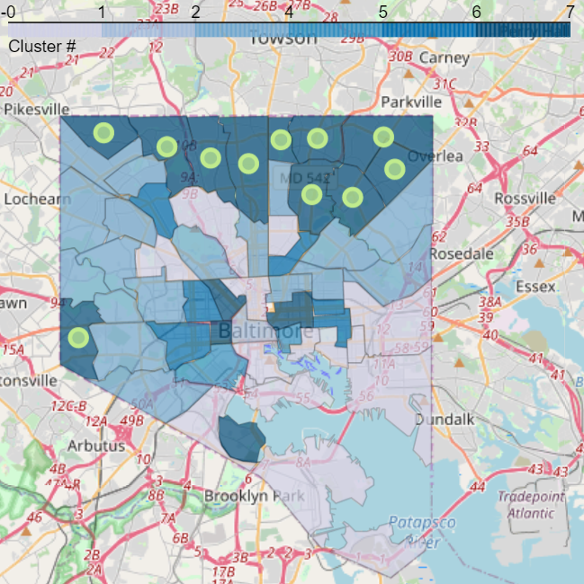

Figure: Cluster #6

Cluster #6 has ‘very low’ crime, ‘high’ median income, ‘moderate’ population density, and the mean average median household size corresponds to ‘mostly couples’. A ‘moderate’ percentage of the population is in the professional age range (25-64). The neighborhoods in this cluster are all near the outer boundary of the city. The most common venues are rather pedestrian and practical: pharmacy, coffee shop, flower shop, bus stop, grocery store.

The location of these neighborhoods, the high median income, moderate population density, and practical venues suggests that these neighborhoods are more suburban in character.

Cluster #6 contains 11 neighborhoods:

* Beechfield/Ten Hills/West Hills
* Chinquapin Park/Belvedere
* Cross-Country/Cheswolde
* Greater Roland Park/Poplar Hill
* Hamilton
* Harford/Echodale
* Lauraville
* Loch Raven
* Mount Washington/Coldspring
* North Baltimore/Guilford/Homeland
* Northwood

See Appendix B for details on each.

## 4.2 Cluster #1:

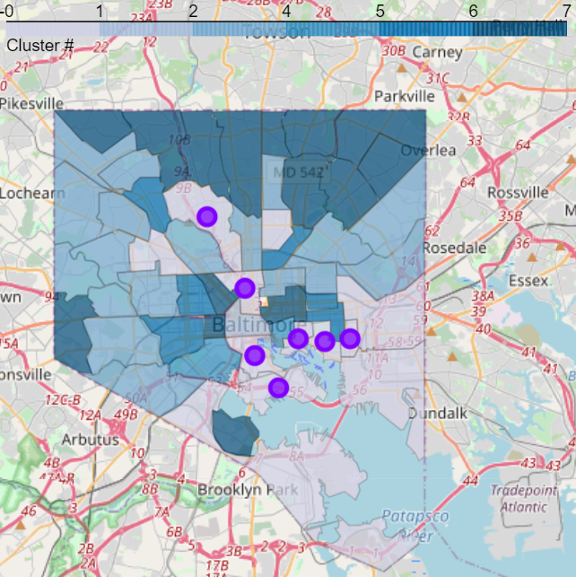

Figure: Cluster #1

Cluster #1 has ‘moderate’ crime, ‘high’ median income, ‘high’ population density, and the mean average median household size corresponds to ‘mostly couples’. A ‘very high’ percentage of the population is in the professional age range (25-64). The neighborhoods in this cluster are all near the center of the city. The most common venues support an active social scene: bar, pizza place, Mexican restaurant, American restaurant, coffee shop.

The location of these neighborhoods, the high median income, high population density, and social venues suggests that this cluster include the trendy urban areas.

Cluster #1 contains 7 neighborhoods:

* Canton
* Fells Point
* Highlandtown
* Inner Harbor/Federal Hill
* Medfield/Hampden/Woodberry/Remington
* South Baltimore
* Midtown

See Appendix B for details on each.

## 4.3 Cluster #3:

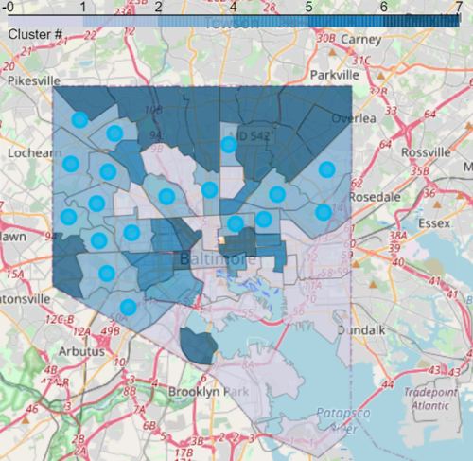

Figure: Cluster #3

Cluster #3 is moderate all around. It has the ‘moderate’ crime, ‘moderate’ median income, ‘moderate’ population density, and the mean average median household size corresponds to ‘mostly couples and small families’. A ‘moderate’ percentage of the population is in the professional age range (25-64). The neighborhoods in this cluster are not as central as cluster #1. Some are closer to the city center than cluster #6. The most common venues are a mixed of social and practical: fried chicken joint, park, convenience store, American restaurant, discount store.

The location of these neighborhoods, the moderate median income, moderate population density, and venues suggests that this cluster include is a transition area between more urban and more suburban areas. The moderate median income and the specific common venues (discount store, convenience store) suggest this cluster is possibly less expensive then clusters #1 and #6.

Cluster #3 contains 18 neighborhoods:

* Allendale/Irvington/S. Hilton
* Belair-Edison
* Cedonia/Frankford
* Claremont/Armistead
* Clifton-Berea
* Dickeyville/Franklintown
* Dorchester/Ashburton
* Edmondson Village
* Forest Park/Walbrook
* Glen-Fallstaff
* Greater Charles Village/Barclay
* Greater Govans
* Greater Rosemont
* Howard Park/West Arlington
* Morrell Park/Violetville
* Penn North/Reservoir Hill
* Pimlico/Arlington/Hilltop
* Greenmount East

See Appendix B for details on each.

# 5. Discussion

## 5.1 Recommendation:

It is recommended that the client consider the neighborhoods in clusters #6, #1, and #3 as she begins her house hunt. (see Appendix A and B for details.) The analysis suggests that:

* Cluster #6 neighborhoods are more suburban in character with very low crime rate.
* Cluster #1 neighborhoods are upscale urban area with social venues, however a moderate crime rate.
* Cluster #3 neighborhoods are transition regions between the urban and suburban areas. They are likely more affordable than Cluster #1 and Cluster #6 but have moderate crime.

## 5.2: Suggested improvements:

This analysis could be improved with more current data, more relevant data, and more accurate data.

**More Current Data:** The crime and census data used was from 2015 and is 5 years old. More current information would improve the accuracy of the analysis. However, much of the relevant features are unlikely to change dramatically over this time frame.

**More Relevant Data**: The client was interested in neighborhoods with ‘like professional’. Additional details on the professional make up of each neighborhood could have improved the analysis. Specifically, average years of education and the types of professions for the population.

**More Accurate Data:** As noted in 3.1.3 the Foursquares venue data collected for this project was rather sparse in some neighborhoods. Consultation with a domain expert confirmed that key venues were missing. More accurate venue information may have resolved the challenges encountered when trying to cluster. Additionally, more accurate venue information would be informative to the client as she reviews the character of the clusters and the neighborhoods.

# 6. Conclusion:

This analysis successfully characterized Baltimore’s neighborhoods in terms of their crime rates, age of the residents, population density, median household income, and venues. The neighborhoods were then clustered based on those factors.

An actionable recommendation was made to the client: the analysis identified three clusters for the client to consider and described the character of each. For each neighborhood in the recommended clusters a detailed report of the character of each neighbor was provided to the client.

The authors wish Jane New Resident the best of luck in her house hunt!

# Appendix A: Cluster Charactereristics:

The characteristics of each cluster when clustering on solely the crime and census data follows. Cluster numbers are arbitrary.

# Cluster 0:

**Summary:** High crime, moderate income, moderate poverty, low population density

**Recommend**: No – high crime.

## Crime:

**Crime:** high, average rate is 88.3 per 1000 people

**Violent Crime:** high, average rate is 23.1 per 1000 people

**Property Crime:** high, average rate is 64.1 per 1000 people

## People:

**Median Income:** moderate, average is 36864.9 dollars per household

**Poverty:** moderate, average percentage of families in poverty is 20.7

**Population Density:** low, average population density is 7.7 people per acre

**25-64 age group**: moderate, average percentage of people in the 25-64 years age group is 54.6

**Household Size:** couples & small families, average average household size is 2.8 people

## Top Venues:

Business Service

Coffee Shop

Discount Store

Train Station

Bus Stop

## Neighborhoods:

Brooklyn/Curtis Bay/Hawkins Point

Greater Mondawmin

Orangeville/East Highlandtown

Southeastern

The Waverlies

Westport/Mount Winans/Lakeland

# Cluster 1:

**Summary:** Moderate crime, High income, low poverty, high population density, mostly couples, bars and restaurants

**Recommend**: Yes. Moderate crime, but trendy urban scene with professionals.

## Crime:

**Crime:** moderate, average rate is 68.2 per 1000 people

**Violent Crime:** moderate, average rate is 11.9 per 1000 people

**Property Crime:** high, average rate is 55.7 per 1000 people

## People:

**Median Income:** high, average is 76007.0 dollars per household

**Poverty:** low, average percentage of families in poverty is 6.4

**Population Density:** high, average population density is 22.1 people per acre

**25-64 age group:** very high, average percentage of people in the 25-64 years age group is 69.4

**Household Size:** mostly couples, average average household size is 2.1 people

## Top Venues:

Bar

Pizza Place

Mexican Restaurant

American Restaurant

Coffee Shop

## Neighborhoods:

Canton

Fells Point

Highlandtown

Inner Harbor/Federal Hill

Medfield/Hampden/Woodberry/Remington

South Baltimore

Midtown

# Cluster 2:

**Summary:** Very high crime

**Recommend**: No. Very high crime.

## Crime:

**Crime:** very high, average rate is 268.2 per 1000 people

**Violent Crime:** very high, average rate is 79.4 per 1000 people

**Property Crime:** very high, average rate is 185.7 per 1000 people

## People:

**Median Income:** moderate, average is 46132.9 dollars per household

**Poverty:** very low, average percentage of families in poverty is 5.5

**Population Density:** low, average population density is 10.3 people per acre

**25-64 age group:** very high, average percentage of people in the 25-64 years age group is 69.8

**Household Size:** mostly singles, average average household size is 1.4 people

## Top Venues:

Café

Coffee Shop

Sandwich Place

Hotel

Deli / Bodega

## Neighborhoods:

Downtown/Seton Hill

# Cluster 3:

**Summary:** Moderate everything.

**Recommend**: Yes. Moderate crime, but may be more affordable, Has a balance of shops and restaurants.

## Crime:

**Crime:** moderate, average rate is 56.2 per 1000 people

**Violent Crime:** moderate, average rate is 14.5 per 1000 people

**Property Crime:** moderate, average rate is 41.0 per 1000 people

## People:

**Median Income:** moderate, average is 35484.7 dollars per household

**Poverty:** moderate, average percentage of families in poverty is 20.7

**Population Density:** moderate, average population density is 13.5 people per acre

**25-64 age group:** moderate, average percentage of people in the 25-64 years age group is 53.3

**Household Size:** couples & small families, average average household size is 2.6 people

## Top Venues:

Fried Chicken Joint

Park

Convenience Store

American Restaurant

Discount Store

## Neighborhoods:

Allendale/Irvington/S. Hilton

Belair-Edison

Cedonia/Frankford

Claremont/Armistead

Clifton-Berea

Dickeyville/Franklintown

Dorchester/Ashburton

Edmondson Village

Forest Park/Walbrook

Glen-Fallstaff

Greater Charles Village/Barclay

Greater Govans

Greater Rosemont

Howard Park/West Arlington

Morrell Park/Violetville

Penn North/Reservoir Hill

Pimlico/Arlington/Hilltop

Greenmount East

# Cluster 4:

**Summary:** Very high crime, moderate income, high poverty, mostly couples, restaurants

**Recommend**: No. Very high crime, high poverty.

## Crime:

**Crime:** very high; average rate is 154.7 per 1000 people

**Violent Crime:** very high, average rate is 29.0 per 1000 people

**Property Crime:** very high, average rate is 123.5 per 1000 people

## People:

**Median Income:** moderate, average is 43536.5 dollars per household

**Poverty:** high, average percentage of families in poverty is 31.4

**Population Density:** moderate, average population density is 14.4 people per acre

**25-64 age group:** high, average percentage of people in the 25-64 years age group is 61.1

**Household Size:** mostly couples, average average household size is 2.4 people

## Top Venues:

Italian Restaurant

Pizza Place

Rental Car Location

Bakery

Mobile Phone Shop

## Neighborhoods:

Washington Village/Pigtown

Harbor East/Little Italy

# Cluster 5:

**Summary:** High crime, low income, high population density, high poverty.

**Recommend**: No. This is a poor, high crime urban area.

## Crime:

**Crime:** high, average rate is 79.3 per 1000 people

**Violent Crime:** high, average rate is 23.3 per 1000 people

**Property Crime:** moderate, average rate is 54.8 per 1000 people

## People:

**Median Income:** low, average is 31578.8 dollars per household

**Poverty:** high, average percentage of families in poverty is 31.6

**Population Density:** very high, average population density is 28.7 people per acre

**25-64 age group:** moderate, average percentage of people in the 25-64 years age group is 54.3

**Household Size:** couples & small families, average average household size is 3.0 people

## Top Venue:

Fast Food Restaurant

Grocery Store

Deli / Bodega

Seafood Restaurant

Fried Chicken Joint

## Neighborhoods:

Madison/East End

Midway/Coldstream

Patterson Park North & East

Sandtown-Winchester/Harlem Park

Southern Park Heights

Southwest Baltimore

# Cluster 6:

**Summary:** Very low crime, high income, mostly couples, moderate population density, shops

**Recommend**: Yes, but more suburban areas.

## Crime:

**Crime:** very low, average rate is 39.8 per 1000 people

**Violent Crime:** low, average rate is 7.0 per 1000 people

**Property Crime:** low, average rate is 32.2 per 1000 people

## People:

**Median Income:** high, average is 63439.3 dollars per household

**Poverty:** low, average percentage of families in poverty is 8.2

**Population Density:** moderate, average population density is 11.3 people per acre

**25-64 age group:** moderate, average percentage of people in the 25-64 years age group is 53.1

**Household Size:** mostly couples, average average household size is 2.4 people

## Top Venues:

Pharmacy

Coffee Shop

Flower Shop

Bus Stop

Grocery Store

## Neighborhoods:

Beechfield/Ten Hills/West Hills

Chinquapin Park/Belvedere

Cross-Country/Cheswolde

Greater Roland Park/Poplar Hill

Hamilton

Harford/Echodale

Lauraville

Loch Raven

Mount Washington/Coldspring

North Baltimore/Guilford/Homeland

Northwood

# Cluster 7:

**Summary:** High crime, very low income, very high poverty, high population density, low percentage of 24-64 year-olds

**Recommend**: No. This is high crime, low income, urban area.

## Crime:

**Crime:** high, average rate is 84.8 per 1000 people

**Violent Crime:** high, average rate is 26.8 per 1000 people

**Property Crime:** high, average rate is 56.7 per 1000 people

## People:

**Median Income:** very low, average is 18154.7 dollars per household

**Poverty:** very high, average percentage of families in poverty is 46.3

**Population Density:** high, average population density is 19.1 people per acre

**25-64 age group:** low, average percentage of people in the 25-64 years age group is 48.2

**Household Size:** mostly couples, average average household size is 2.4 people

## Top Venues:

Pizza Place

Grocery Store

Market

Bus Stop

Coffee Shop

## Neighborhoods:

Cherry Hill

Poppleton/The Terraces/Hollins Market

Oldtown/Middle East

Upton/Druid Heights

# Appendix B: Recommended Neighborhoods

A total of 36 neighborhoods are recommended for consideration.

## Cluster 6:

### Greater Roland Park/Poplar Hill:

Cluster: 6

Crime:

* Crime: very low, 27.9 per 1000 people
* Violent Crime: very low, 4.2 per 1000 people
* Property Crime: very low, 23.5 per 1000 people

People:

* Median Income: very high, 105555.3 dollars per household
* Poverty: very low, percentage of families in poverty is 3.8
* Population Density: low, population density is 5.2 people per acre
* 25-64 age group: low, percentage population is 49.9
* Household Size: mostly couples, average household size is 2.0 people

Top Venues:

* Bank
* Flower Shop
* Pharmacy
* Grocery Store
* Coffee Shop
* Yoga Studio
* Food Truck

### Loch Raven:

Cluster: 6

Crime:

* Crime: very low, 39.4 per 1000 people
* Violent Crime: low, 8.9 per 1000 people
* Property Crime: very low, 29.6 per 1000 people

People:

* Median Income: moderate, 47461.9 dollars per household
* Poverty: moderate, percentage of families in poverty is 12.1
* Population Density: moderate, population density is 17.0 people per acre
* 25-64 age group: moderate, percentage population is 52.8
* Household Size: couples & small families, average household size is 2.6 people

Top Venues:

* Bank
* Dry Cleaner
* Park
* Gym / Fitness Center
* Auto Garage
* Liquor Store
* Bus Stop

### Northwood:

Cluster: 6

Crime:

* Crime: low, 42.3 per 1000 people
* Violent Crime: low, 10.5 per 1000 people
* Property Crime: very low, 30.6 per 1000 people

People:

* Median Income: high, 53974.3 dollars per household
* Poverty: low, percentage of families in poverty is 8.0
* Population Density: moderate, population density is 11.3 people per acre
* 25-64 age group: very low, percentage population is 42.7
* Household Size: couples & small families, average household size is 2.6 people

Top Venues:

* Food Service
* American Restaurant
* Pharmacy
* Pizza Place
* Yoga Studio
* Fast Food Restaurant
* Food Truck

### Hamilton:

Cluster: 6

Crime:

* Crime: low, 47.5 per 1000 people
* Violent Crime: low, 9.5 per 1000 people
* Property Crime: low, 37.1 per 1000 people

People:

* Median Income: high, 63600.2 dollars per household
* Poverty: low, percentage of families in poverty is 8.7
* Population Density: moderate, population density is 12.8 people per acre
* 25-64 age group: high, percentage population is 57.8
* Household Size: couples & small families, average household size is 2.6 people

Top Venues:

* Travel & Transport
* Home Service
* Event Service
* Farm
* Food Truck
* Food Service
* Food Court

### Harford/Echodale:

Cluster: 6

Crime:

* Crime: low, 45.7 per 1000 people
* Violent Crime: low, 10.0 per 1000 people
* Property Crime: low, 34.5 per 1000 people

People:

* Median Income: high, 52708.1 dollars per household
* Poverty: low, percentage of families in poverty is 9.3
* Population Density: low, population density is 10.7 people per acre
* 25-64 age group: high, percentage population is 60.1
* Household Size: mostly couples, average household size is 2.4 people

Top Venues:

* Pharmacy
* Italian Restaurant
* Martial Arts Dojo
* BBQ Joint
* Thai Restaurant
* Candy Store
* Gas Station

### Lauraville:

Cluster: 6

Crime:

* Crime: low, 41.9 per 1000 people
* Violent Crime: low, 8.1 per 1000 people
* Property Crime: low, 33.2 per 1000 people

People:

* Median Income: high, 66010.9 dollars per household
* Poverty: low, percentage of families in poverty is 9.4
* Population Density: low, population density is 10.7 people per acre
* 25-64 age group: high, percentage population is 61.0
* Household Size: couples & small families, average household size is 2.7 people

Top Venues:

* Coffee Shop
* Farmers Market
* Vegetarian / Vegan Restaurant
* Bus Stop
* Bookstore
* Flower Shop
* Grocery Store

### Beechfield/Ten Hills/West Hills:

Cluster: 6

Crime:

* Crime: very low, 37.3 per 1000 people
* Violent Crime: low, 7.9 per 1000 people
* Property Crime: very low, 28.9 per 1000 people

People:

* Median Income: high, 51537.6 dollars per household
* Poverty: moderate, percentage of families in poverty is 11.2
* Population Density: moderate, population density is 12.2 people per acre
* 25-64 age group: moderate, percentage population is 56.4
* Household Size: couples & small families, average household size is 2.6 people

Top Venues:

* ATM
* Residential Building (Apartment / Condo)
* Pool
* Restaurant
* Discount Store
* Food Service
* Food Court

### Cross-Country/Cheswolde:

Cluster: 6

Crime:

* Crime: very low, 23.7 per 1000 people
* Violent Crime: very low, 0.9 per 1000 people
* Property Crime: very low, 22.5 per 1000 people

People:

* Median Income: high, 55964.3 dollars per household
* Poverty: low, percentage of families in poverty is 8.1
* Population Density: moderate, population density is 16.0 people per acre
* 25-64 age group: very low, percentage population is 45.5
* Household Size: couples & small families, average household size is 2.6 people

Top Venues:

* River
* Yoga Studio
* Farm
* Food Truck
* Food Service
* Food Court
* Food & Drink Shop

### Mount Washington/Coldspring:

Cluster: 6

Crime:

* Crime: low, 41.0 per 1000 people
* Violent Crime: very low, 4.6 per 1000 people
* Property Crime: low, 35.6 per 1000 people

People:

* Median Income: high, 77390.2 dollars per household
* Poverty: very low, percentage of families in poverty is 5.1
* Population Density: very low, population density is 3.6 people per acre
* 25-64 age group: high, percentage population is 57.4
* Household Size: mostly couples, average household size is 1.9 people

Top Venues:

* Park
* Café
* Mini Golf
* Yoga Studio
* Fried Chicken Joint
* Food Truck
* Food Service

### North Baltimore/Guilford/Homeland:

Cluster: 6

Crime:

* Crime: very low, 38.3 per 1000 people
* Violent Crime: very low, 4.5 per 1000 people
* Property Crime: low, 33.6 per 1000 people

People:

* Median Income: very high, 78174.8 dollars per household
* Poverty: very low, percentage of families in poverty is 5.8
* Population Density: low, population density is 8.4 people per acre
* 25-64 age group: very low, percentage population is 46.1
* Household Size: mostly couples, average household size is 2.3 people

Top Venues:

* Wings Joint
* Social Club
* Gym
* Yoga Studio
* Farmers Market
* Food Truck
* Food Service

### Chinquapin Park/Belvedere:

Cluster: 6

Crime:

* Crime: moderate, 52.5 per 1000 people
* Violent Crime: low, 7.6 per 1000 people
* Property Crime: moderate, 44.7 per 1000 people

People:

* Median Income: moderate, 45454.5 dollars per household
* Poverty: low, percentage of families in poverty is 8.9
* Population Density: moderate, population density is 16.9 people per acre
* 25-64 age group: moderate, percentage population is 54.6
* Household Size: mostly couples, average household size is 2.4 people

Top Venues:

* Juice Bar
* Gift Shop
* Dessert Shop
* Ramen Restaurant
* Deli / Bodega
* Sandwich Place
* Eye Doctor

## Cluster 3:

### Cedonia/Frankford:

Cluster: 3

Crime:

* Crime: moderate, 53.6 per 1000 people
* Violent Crime: moderate, 11.7 per 1000 people
* Property Crime: moderate, 41.5 per 1000 people

People:

* Median Income: moderate, 39300.4 dollars per household
* Poverty: moderate, percentage of families in poverty is 16.9
* Population Density: moderate, population density is 14.5 people per acre
* 25-64 age group: high, percentage population is 59.0
* Household Size: couples & small families, average household size is 2.5 people

Top Venues:

* Garden
* Indian Restaurant
* Chinese Restaurant
* Yoga Studio
* Fast Food Restaurant
* Food Truck
* Food Service

### Glen-Fallstaff:

Cluster: 3

Crime:

* Crime: moderate, 55.0 per 1000 people
* Violent Crime: moderate, 13.5 per 1000 people
* Property Crime: moderate, 40.8 per 1000 people

People:

* Median Income: moderate, 39690.8 dollars per household
* Poverty: moderate, percentage of families in poverty is 19.8
* Population Density: moderate, population density is 16.0 people per acre
* 25-64 age group: low, percentage population is 50.2
* Household Size: couples & small families, average household size is 2.6 people

Top Venues:

* American Restaurant
* Rental Car Location
* Liquor Store
* Yoga Studio
* Farmers Market
* French Restaurant
* Food Truck

### Forest Park/Walbrook:

Cluster: 3

Crime:

* Crime: moderate, 51.7 per 1000 people
* Violent Crime: moderate, 12.0 per 1000 people
* Property Crime: moderate, 39.5 per 1000 people

People:

* Median Income: moderate, 39204.8 dollars per household
* Poverty: moderate, percentage of families in poverty is 20.3
* Population Density: low, population density is 10.6 people per acre
* 25-64 age group: moderate, percentage population is 54.5
* Household Size: mostly couples, average household size is 2.4 people

Top Venues:

* Construction & Landscaping
* Yoga Studio
* Farmers Market
* French Restaurant
* Food Truck
* Food Service
* Food Court

### Edmondson Village:

Cluster: 3

Crime:

* Crime: low, 42.2 per 1000 people
* Violent Crime: low, 9.6 per 1000 people
* Property Crime: low, 32.0 per 1000 people

People:

* Median Income: moderate, 38042.4 dollars per household
* Poverty: moderate, percentage of families in poverty is 16.0
* Population Density: moderate, population density is 15.7 people per acre
* 25-64 age group: low, percentage population is 51.7
* Household Size: couples & small families, average household size is 2.9 people

Top Venues:

* Convenience Store
* Auto Garage
* Yoga Studio
* Farmers Market
* French Restaurant
* Food Truck
* Food Service

### Greenmount East:

Cluster: 3

Crime:

* Crime: moderate, 76.0 per 1000 people
* Violent Crime: high, 22.6 per 1000 people
* Property Crime: moderate, 52.4 per 1000 people

People:

* Median Income: very low, 23625.8 dollars per household
* Poverty: high, percentage of families in poverty is 25.8
* Population Density: moderate, population density is 17.2 people per acre
* 25-64 age group: moderate, percentage population is 53.1
* Household Size: couples & small families, average household size is 2.6 people

Top Venues:

* Farmers Market
* Drugstore
* Grocery Store
* Community Center
* Flower Shop
* Convenience Store
* Basketball Court

### Greater Charles Village/Barclay:

Cluster: 3

Crime:

* Crime: moderate, 71.1 per 1000 people
* Violent Crime: high, 21.4 per 1000 people
* Property Crime: moderate, 49.2 per 1000 people

People:

* Median Income: low, 32241.1 dollars per household
* Poverty: moderate, percentage of families in poverty is 23.8
* Population Density: high, population density is 22.3 people per acre
* 25-64 age group: low, percentage population is 52.1
* Household Size: mostly couples, average household size is 2.1 people

Top Venues:

* Pizza Place
* Café
* Convenience Store
* Brewery
* Chinese Restaurant
* Coffee Shop
* Sculpture Garden

### Dickeyville/Franklintown:

Cluster: 3

Crime:

* Crime: very low, 31.9 per 1000 people
* Violent Crime: low, 7.1 per 1000 people
* Property Crime: very low, 24.6 per 1000 people

People:

* Median Income: moderate, 35773.0 dollars per household
* Poverty: moderate, percentage of families in poverty is 21.2
* Population Density: very low, population density is 4.6 people per acre
* 25-64 age group: moderate, percentage population is 53.7
* Household Size: mostly couples, average household size is 2.2 people

Top Venues:

* Garden
* Waterfall
* Home Service
* Yoga Studio
* Farmers Market
* Food Truck
* Food Service

### Clifton-Berea:

Cluster: 3

Crime:

* Crime: moderate, 66.5 per 1000 people
* Violent Crime: high, 23.7 per 1000 people
* Property Crime: moderate, 41.2 per 1000 people

People:

* Median Income: low, 29364.2 dollars per household
* Poverty: moderate, percentage of families in poverty is 23.6
* Population Density: moderate, population density is 16.1 people per acre
* 25-64 age group: moderate, percentage population is 53.1
* Household Size: couples & small families, average household size is 2.7 people

Top Venues:

* Wings Joint
* Bus Stop
* Food
* Park
* Public Art
* Yoga Studio
* Farmers Market

### Claremont/Armistead:

Cluster: 3

Crime:

* Crime: low, 48.1 per 1000 people
* Violent Crime: moderate, 11.5 per 1000 people
* Property Crime: low, 35.8 per 1000 people

People:

* Median Income: low, 33179.5 dollars per household
* Poverty: moderate, percentage of families in poverty is 21.3
* Population Density: low, population density is 5.9 people per acre
* 25-64 age group: moderate, percentage population is 54.5
* Household Size: mostly couples, average household size is 2.4 people

Top Venues:

* Gas Station
* Hotel
* Fast Food Restaurant
* Yoga Studio
* Farmers Market
* Food Truck
* Food Service

### Dorchester/Ashburton:

Cluster: 3

Crime:

* Crime: low, 50.3 per 1000 people
* Violent Crime: moderate, 12.6 per 1000 people
* Property Crime: low, 36.7 per 1000 people

People:

* Median Income: moderate, 38682.9 dollars per household
* Poverty: moderate, percentage of families in poverty is 18.8
* Population Density: moderate, population density is 15.0 people per acre
* 25-64 age group: low, percentage population is 51.9
* Household Size: couples & small families, average household size is 2.7 people

Top Venues:

* Fried Chicken Joint
* Food
* Grocery Store
* Chinese Restaurant
* Frozen Yogurt Shop
* French Restaurant
* Food Truck

### Belair-Edison:

Cluster: 3

Crime:

* Crime: moderate, 52.5 per 1000 people
* Violent Crime: moderate, 11.8 per 1000 people
* Property Crime: moderate, 39.4 per 1000 people

People:

* Median Income: moderate, 38174.0 dollars per household
* Poverty: moderate, percentage of families in poverty is 18.6
* Population Density: moderate, population density is 15.8 people per acre
* 25-64 age group: moderate, percentage population is 54.7
* Household Size: couples & small families, average household size is 2.8 people

Top Venues:

* Fried Chicken Joint
* Discount Store
* ATM
* Chinese Restaurant
* Grocery Store
* Food & Drink Shop
* Pharmacy

### Greater Govans:

Cluster: 3

Crime:

* Crime: low, 49.0 per 1000 people
* Violent Crime: moderate, 11.3 per 1000 people
* Property Crime: low, 37.3 per 1000 people

People:

* Median Income: moderate, 37457.3 dollars per household
* Poverty: moderate, percentage of families in poverty is 21.3
* Population Density: high, population density is 20.9 people per acre
* 25-64 age group: low, percentage population is 52.1
* Household Size: couples & small families, average household size is 2.7 people

Top Venues:

* Gym / Fitness Center
* Home Service
* Fried Chicken Joint
* Coffee Shop
* Weight Loss Center
* Laundromat
* Snack Place

### Greater Rosemont:

Cluster: 3

Crime:

* Crime: moderate, 63.2 per 1000 people
* Violent Crime: moderate, 15.5 per 1000 people
* Property Crime: moderate, 46.8 per 1000 people

People:

* Median Income: low, 31759.1 dollars per household
* Poverty: moderate, percentage of families in poverty is 21.3
* Population Density: moderate, population density is 16.2 people per acre
* 25-64 age group: moderate, percentage population is 52.6
* Household Size: couples & small families, average household size is 2.7 people

Top Venues:

* Intersection
* Lounge
* Deli / Bodega
* Indian Restaurant
* Ice Cream Shop
* Food Truck
* Food Service

### Howard Park/West Arlington:

Cluster: 3

Crime:

* Crime: low, 48.5 per 1000 people
* Violent Crime: low, 10.9 per 1000 people
* Property Crime: low, 37.1 per 1000 people

People:

* Median Income: moderate, 41821.9 dollars per household
* Poverty: moderate, percentage of families in poverty is 19.5
* Population Density: low, population density is 7.1 people per acre
* 25-64 age group: low, percentage population is 49.2
* Household Size: couples & small families, average household size is 2.6 people

Top Venues:

* Discount Store
* Bus Stop
* Lawyer
* Yoga Studio
* Fast Food Restaurant
* French Restaurant
* Food Truck

### Morrell Park/Violetville:

Cluster: 3

Crime:

* Crime: moderate, 67.0 per 1000 people
* Violent Crime: moderate, 14.1 per 1000 people
* Property Crime: moderate, 52.5 per 1000 people

People:

* Median Income: moderate, 35687.4 dollars per household
* Poverty: moderate, percentage of families in poverty is 12.5
* Population Density: very low, population density is 5.0 people per acre
* 25-64 age group: moderate, percentage population is 56.7
* Household Size: mostly couples, average household size is 2.3 people

Top Venues:

* Construction & Landscaping
* Hobby Shop
* Yoga Studio
* Farmers Market
* French Restaurant
* Food Truck
* Food Service

### Penn North/Reservoir Hill:

Cluster: 3

Crime:

* Crime: moderate, 64.2 per 1000 people
* Violent Crime: moderate, 15.8 per 1000 people
* Property Crime: moderate, 47.0 per 1000 people

People:

* Median Income: low, 34879.3 dollars per household
* Poverty: high, percentage of families in poverty is 29.3
* Population Density: moderate, population density is 11.5 people per acre
* 25-64 age group: moderate, percentage population is 55.6
* Household Size: couples & small families, average household size is 2.5 people

Top Venues:

* Park
* Botanical Garden
* Basketball Court
* Farmers Market
* Baseball Field
* Track
* Yoga Studio

### Pimlico/Arlington/Hilltop:

Cluster: 3

Crime:

* Crime: moderate, 61.6 per 1000 people
* Violent Crime: high, 20.9 per 1000 people
* Property Crime: moderate, 39.4 per 1000 people

People:

* Median Income: low, 33139.2 dollars per household
* Poverty: moderate, percentage of families in poverty is 17.4
* Population Density: moderate, population density is 16.8 people per acre
* 25-64 age group: moderate, percentage population is 54.3
* Household Size: couples & small families, average household size is 2.9 people

Top Venues:

* Fried Chicken Joint
* Caribbean Restaurant
* Deli / Bodega
* Clothing Store
* Racetrack
* Storage Facility
* Convenience Store

### Allendale/Irvington/S. Hilton:

Cluster: 3

Crime:

* Crime: moderate, 59.3 per 1000 people
* Violent Crime: moderate, 15.0 per 1000 people
* Property Crime: moderate, 43.8 per 1000 people

People:

* Median Income: moderate, 36701.9 dollars per household
* Poverty: high, percentage of families in poverty is 24.1
* Population Density: moderate, population density is 10.9 people per acre
* 25-64 age group: low, percentage population is 51.0
* Household Size: couples & small families, average household size is 2.7 people

Top Venues:

* Fried Chicken Joint
* Karaoke Bar
* Discount Store
* Cosmetics Shop
* Bus Stop
* Flower Shop
* Thrift / Vintage Store

## Cluster 1:

## Inner Harbor/Federal Hill:

Cluster: 1

Crime:

* Crime: moderate, 65.9 per 1000 people
* Violent Crime: moderate, 11.0 per 1000 people
* Property Crime: moderate, 54.5 per 1000 people

People:

* Median Income: very high, 88465.2 dollars per household
* Poverty: low, percentage of families in poverty is 7.5
* Population Density: high, population density is 23.6 people per acre
* 25-64 age group: very high, percentage population is 67.5
* Household Size: mostly couples, average household size is 2.0 people

Top Venues:

* Bar
* Pizza Place
* Mexican Restaurant
* Sushi Restaurant
* Café
* Mediterranean Restaurant
* Pub

### Fells Point:

Cluster: 1

Crime:

* Crime: high, 80.2 per 1000 people
* Violent Crime: moderate, 16.6 per 1000 people
* Property Crime: high, 62.6 per 1000 people

People:

* Median Income: very high, 82263.2 dollars per household
* Poverty: low, percentage of families in poverty is 6.2
* Population Density: very high, population density is 33.8 people per acre
* 25-64 age group: very high, percentage population is 77.5
* Household Size: mostly couples, average household size is 2.1 people

Top Venues:

* Bar
* Seafood Restaurant
* Mexican Restaurant
* American Restaurant
* Latin American Restaurant
* Cocktail Bar
* Sushi Restaurant

### Highlandtown:

Cluster: 1

Crime:

* Crime: high, 94.9 per 1000 people
* Violent Crime: moderate, 17.4 per 1000 people
* Property Crime: very high, 76.8 per 1000 people

People:

* Median Income: high, 68702.2 dollars per household
* Poverty: low, percentage of families in poverty is 9.6
* Population Density: very high, population density is 27.4 people per acre
* 25-64 age group: very high, percentage population is 65.6
* Household Size: mostly couples, average household size is 2.3 people

Top Venues:

* Dive Bar
* New American Restaurant
* Pizza Place
* Hot Dog Joint
* Mexican Restaurant
* Supermarket
* Pharmacy

### Canton:

Cluster: 1

Crime:

* Crime: moderate, 51.2 per 1000 people
* Violent Crime: very low, 4.6 per 1000 people
* Property Crime: moderate, 46.5 per 1000 people

People:

* Median Income: very high, 95362.4 dollars per household
* Poverty: very low, percentage of families in poverty is 3.0
* Population Density: high, population density is 22.2 people per acre
* 25-64 age group: very high, percentage population is 74.0
* Household Size: mostly couples, average household size is 2.0 people

Top Venues:

* Bar
* American Restaurant
* Gym / Fitness Center
* Pub
* Pizza Place
* Mexican Restaurant
* Ice Cream Shop

### South Baltimore:

Cluster: 1

Crime:

* Crime: low, 41.8 per 1000 people
* Violent Crime: very low, 3.3 per 1000 people
* Property Crime: moderate, 38.1 per 1000 people

People:

* Median Income: very high, 97441.0 dollars per household
* Poverty: very low, percentage of families in poverty is 3.7
* Population Density: low, population density is 6.7 people per acre
* 25-64 age group: very high, percentage population is 74.7
* Household Size: mostly couples, average household size is 2.2 people

Top Venues:

* Cruise
* Pet Store
* Coffee Shop
* Bar
* Buffet
* Shopping Mall
* Brewery

### Midtown:

Cluster: 1

Crime:

* Crime: high, 87.5 per 1000 people
* Violent Crime: moderate, 19.6 per 1000 people
* Property Crime: high, 67.0 per 1000 people

People:

* Median Income: moderate, 41170.5 dollars per household
* Poverty: low, percentage of families in poverty is 7.6
* Population Density: very high, population density is 28.5 people per acre
* 25-64 age group: high, percentage population is 61.9
* Household Size: mostly couples, average household size is 1.8 people

Top Venues:

* Pizza Place
* Deli / Bodega
* Sandwich Place
* Bar
* Arts & Crafts Store
* Sushi Restaurant
* Gay Bar

### Medfield/Hampden/Woodberry/Remington:

Cluster: 1

Crime:

* Crime: moderate, 55.8 per 1000 people
* Violent Crime: low, 10.7 per 1000 people
* Property Crime: moderate, 44.7 per 1000 people

People:

* Median Income: high, 58644.2 dollars per household
* Poverty: low, percentage of families in poverty is 7.1
* Population Density: moderate, population density is 12.2 people per acre
* 25-64 age group: high, percentage population is 64.4
* Household Size: mostly couples, average household size is 2.2 people

Top Venues:

* American Restaurant
* Bar
* Pizza Place
* Food Truck
* Brewery
* Italian Restaurant
* Mexican Restaurant

1. <https://en.wikipedia.org/wiki/Baltimore>